CS3249 GUI Design Progress Report Microscope Team QX

Kit Wei Min A0115384 Wong Wei Jie Bob A0094718 Oh Qi Xuan A0096911

# Software Architecture

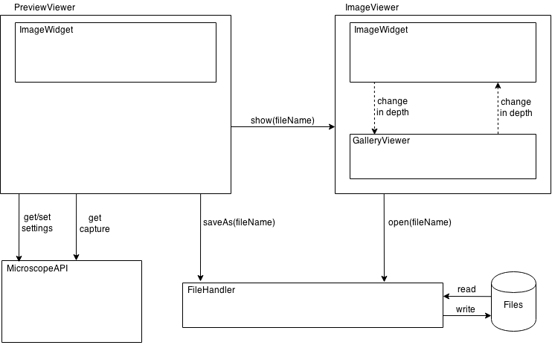

# G[1]UI Design

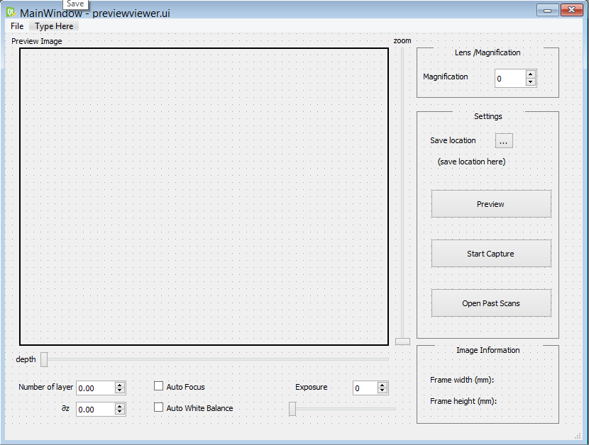

Based on the initial microscope design from tutorial 1, we are proposing a revamped GUI with several elements that emphasize aspects of the program important to the user, and de-emphasize lesser-used but still important elements.

First of all, instead of a large preview button, most of the space is taken up by a frame intended to contain the preview image. This frame updates only when the Preview button is pressed, to allow the user a fixed frame of reference when adjusting settings. We believe this is the main focus of the application and should be sized accordingly, as opposed to being assigned to another button as in the prior design. Allowing the frame to be in the same window as most of the application’s options enables fast review of changes. The frame is positioned on the upper left, as this allows it to be viewable easily at eye level as opposed to being positioned lower down, which may necessitate looking down at a slight incline and aggravate neck strain and user irritation.

Most users work with the typical layout where the mouse is on the right-hand side and the keyboard is on the left – as such, to facilitate mouse movement, often-used elements should be on the right, while rarely used ones should be on the left. Exposure, auto white balance and auto focus are three features which enhance the quality of the image to the user’s specifications; however, once set, they are seldom used afterwards. As such, these UI elements are relegated to the bottom-left of the application, where they are non-obtrusive but still available to the user for information and modification.

Magnification is located on the top right of the GUI, as an important but infrequently-used component. Though a slider may intuitively be an option, we believe that this would only introduce unnecessary clutter to the interface, as most uses of microscopes have different magnification options purely for versatility in perusing different samples, and do not require fast iteration through different magnification options. A spin box is sufficient to both allow modification of the magnification and display it.

Image information is located at the bottom-right corner of the GUI. This contains information about the size of the image, which could be important information to some users. This is displayed where it can be easily located, yet will not divert attention from the preview image.

Settings are located below magnification, and contains options to select save location and the buttons for Preview, Start Capture and Open Past Scans.

Selecting Start Capture will open up a dialog that informs the user that the scan is ongoing. Selecting Open Past Scans will open the file dialog for the user to select the folder storing the scans that the user is interested in. The GUI will then be updated to a new view as shown below.

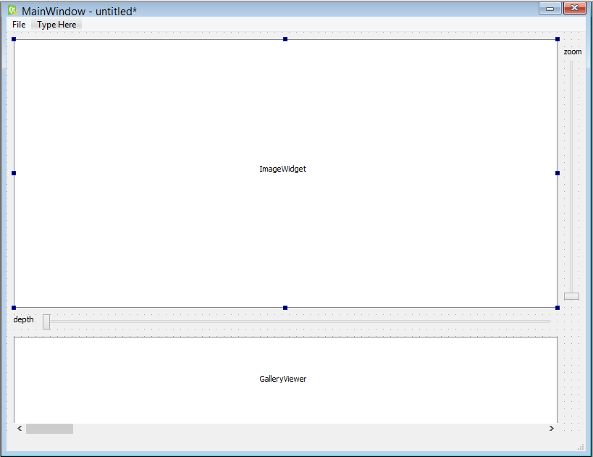

The main viewer now occupies the bulk of the window box. Sliders are used to zoom in on the image and to scroll through the different layers, though for advanced users, controls using the mouse and keyboard will be implemented as well. Users can also get a preview of all the different layers with the photo gallery located below the main viewer, and can select a particular layer by clicking on the image as well. The scrolling of the photo gallery will be synced with the slider that controls depth, so that the user can have a view of the surrounding layers while scrutinising a particular area in the main viewer.

We realise that users might want to be able to do side-by-side comparisions between past scans and what they are observing real-time, and thus we are offering a third view, with both views combined and placed alongside each other for easier comparision. This is shown below.

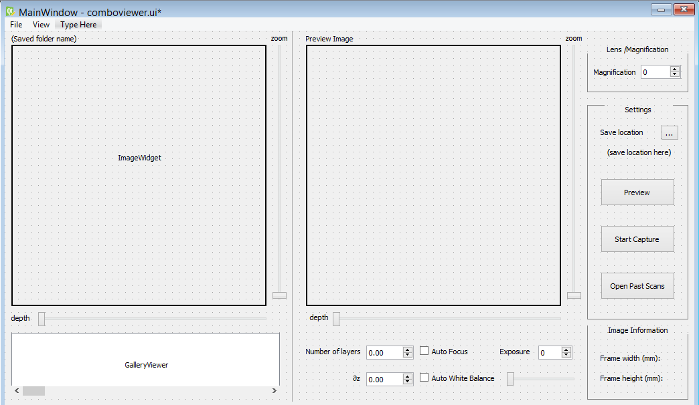

1.